EMPOWERING BETTER HEALTH
via the alchemy of life

Homeopathy: Can it be safely used on Children?
The simple answer is yes. There are many instances when homeopathy can safely help or augment conventional treatments in children. From colds, coughs and ear infections to rashes, allergies and behavioral issues, homeopathy has been shown to successfully assist in the treatment of many childhood complaints. The number one reason that parents bring their children to a homeopath is because homeopathic medicines are so much safer than conventional medicines. The second main reason that parents bring their children to homeopaths is that children respond so well to homeopathic medicines. You can really change a child's life, both physical and psychologically, with the correct homeopathic remedy.

How do children respond to homeopathic remedies?
Children respond extremely well to homeopathic remedies, even when the perfect medicine is not always prescribed. It is as though the intelligence in their body is so high that their internal radar is scanning for any energetic medicine that is even close to being the best one. Famed astronomer Johann Kepler once said, "Nature uses as little as possible of anything." The fact that children respond so well to homeopathic medicines is one further example of this.

Where can I find homeopathic remedies?
Homeopathic remedies can be found at health food stores, grocery stores and even some drug stores. They are usually in the children’s section and near Airborne products. Below are some suggestions to have on hand:

Hyland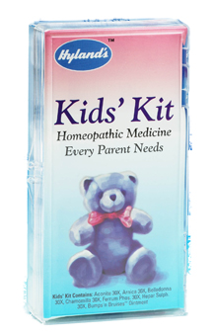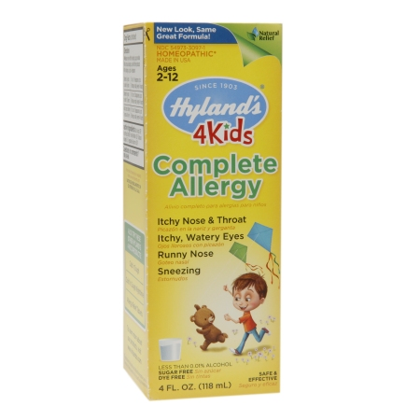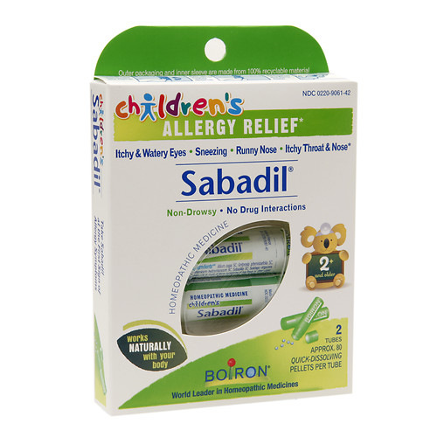's Kids' Kit contains seperately:
Aconitum Napellus 30X: sudden colds or fever
Arnica Montana 30X: bruising, muscle soreness
Belladonna 30X: fever, redness or throbbing pain
Chamomilla 30X: teething, irritability
Ferrum Phos 30X: fever, redness or fatigue
Hepar Sulphuris Calc 30X: cough, colds or skin eruptions

The main difference between homeopaths & regular pediatricians is the way a pediatrician will rush in with drugs to stop a fever…
Anxieties and fears are significant with regard to a child's fever, however it is important to understand the wisdom of the body and how fever is an important defense. Physicians and physiologists today recognize that fever is a useful response of a person's body to infection. While it is true that certain high or long-lasting fevers need to be treated or suppressed in some way, such fevers represent an extreme minority of fevers in children.

Homeopathic medicines usually work very effectively and rapidly in fevers. Because a fever is a defense, the body will make good use of additional tools that it is given to help in its defense. This is distinct from conventional drugs, especially anti-inflammatory drugs, that ultimately are obstacles to the true cure. CAUTION: A child should be taken to a medical physician for immediate medical treatment if fever is experienced in newborns (within first 4 months) that does not respond to homeopathic treatment within two hours, or if a fever in any child is over 103 degrees Fahrenheit and doesn't respond to home treatment after 6 hours, or if high fever in any child leads to great lethargy and neck stiffness.
Can homeopathy help with issues such as ear infections?
The American Academy of Pediatrics' guidelines for the use of antibiotics in acute ear infections in children is actually that they be avoided for the first three months. It may surprise some people to learn that a meta-analysis of the best studies on ear infection (British Medical Journal, 1997, 87:pp.466-74) found no benefit of using antibiotics as compared to placebo. To make matters worse, some evidence suggests that administration of antibiotics lead to three times the number of ear infections as those children left untreated.

Homeopathy is magnificent for the treatment for childhood ear infections. It is often as simply as ABC + P: Aconitum, Belladonna, Chamomilla, & Pulsatilla…with less common use of Mercurius, Mercurius iodatus flavus, Mercurius iodatus ruber, Hepar sulphur, and Silicea. Results are often rapid, but even when they aren't, it seems
as though these children still aren't getting as many ear infections as those for whom antibiotics are prescribed.
According to a recent study of 75 children with otitis media, published in Pediatric Infectious Disease Journal, parent's diary scores showed a significant decrease in symptoms at 24 and 64 hours after treatment in favor of those given a homeopathic medicine (P<.05). There were also 20% less "treatment failures" in children given a homeopathic medicine as compared with those given a placebo. [Reference: J Jacobs, DA Springer, D Crothers, Homeopathic Treatment of Acute Otitis Media in Children: A Preliminary Randomized Placebo-controlled Trial, Pediatric Infectious Disease Journal, 20,2 (February 2001):177-183.]

The more serious the pain and discomfort, generally the faster the relief. It is as though their defenses are so strong that the homeopathic medicine provides a greater and faster relief than those with mild, persistent discomfort. Typically, the relief from a homeopathic medicine is within a couple of hours and certainly after one night's rest.

Selection of remedy best suited based on overall symptoms. Single remedy dosage: 12C or 30C – repeat every 2-4 hours in severe pain and every 4-6 hours in mild. If no change after 24 hours, consider another remedy. Always stop taking the medicine once obvious improvement begins start taking it again if pain returns.

Can homeopathy help issues with Attention Deficit and Hyperactivity problems?
Homeopathic remedies are wonderfully effective for hyperactive children (and hyperactive adults), though this doesn't necessarily mean that a remedy will "cure" them. Sometimes, the remedy will simply slow them down and help them feel more in control of their energy. One study of 43 children with hyperactivity found a statistically significant benefit in those given an individually chosen homeopathic remedy. After the first phase of the study, the children who were given a placebo were then given a homeopathic medicine, and there was again a statistically significant improvement in their health.
[Ref: Frei, H, Everts R, von Ammon K, Kaufmann F, Walther D, Hsu-Schmitz SF, Collenberg M, Fuhrer K, Hassink R, Steinlin M, Thurneysen A. Homeopathic treatment of children with attention deficit hyperactivity disorder: a randomised, double blind, placebo controlled crossover trial. Eur J Pediatr., July 27,2005;164:758-767. John Lamont, "Homeopathic Treatment of Attention Deficit Hyperactivity Disorder," British Homeopathic Journal, Vol. 86, October, 1997, 196-200.]

Homeopathic remedies can elicit a deep and powerful healing that truly changes the child's personality. It is as though the remedy helped pull off a veil of disease that embodied the child. Hyperactivity sometimes requires a constitutional remedy rather than an acute one. Mind you, acute remedies may provide short-term relief, but such relief is not what most children and what parents want. They want long-term improvement. The course of treatment may require miasmatic remedies and other remedies based on etiology of the child's problem (a "miasm" is the homeopathic concept of an underlying genetic and/or acquired chronic disease from which various chronic and acute symptoms manifest). A miasm can be the result of a previous infection or environmental toxin that a person or one of his/her ancestors experienced and never adequately recovered from.
Judyth Reichenberg-Ullman, ND, and Robert Ullman, ND have written two books on the subject of hyperactivity, both of which are helpful to parents: Ritalin Free Kids, and Rage Free Kids.
[Ref: Dr. Dana Ullaman, MPH]

EMPOWERING BETTER HEALTH, LLC Copyright 2015

www.EmpoweringBetterHealth.ORG
614.805.7933

